

helping people **meet Jesus, become like Him** and be **equipped to impact** the local and global community

**York St Small Groups**

**Sermon Based Studies**

SUNDAY 15 JULY 2018

SPEAKER: Pastor Greg Illingworth

**GOD LOVES LOST THINGS. Part 2 – Luke 15**



**Please note that these studies are designed to be explored after hearing the Sunday Sermon and also to be accompanied by a time of prayer/sharing and supper.**

**To listen to this message again please head to the**

**York St Website or download from iTunes.**

**Webpage: www.yorkst.com.au**

**GETTING STARTED**

helping people **meet Jesus, become like Him** and be **equipped to impact** the local and global community

helping people **meet Jesus, become like Him** and be **equipped to impact** the local and global community

**Question #1**

Re-cap and spend some time telling “your story”.

Did you get to share it with anyone during the week?

**Question #2**

Spend some time thinking about…”God’s story “Below is an explanation about an evangelism tool known as the “3 circles”. Pastor Greg explained this tool in our 3 services on the 15th of July.

Below is a reminder of the picture and a sample conversation in how you might go about sharing “God’s story”. The story may appear a bit unlikely or even “lame”…but we get the picture.

Here it is!

The 3 Circles is more than a simple gospel presentation, it’s an interactive tactic for:

* guiding a conversation to include the gospel
* telling God’s story within your own story
* inviting a response
* training new believers to do the same.

A Sample Conversation

Let’s join Chris and Larry mid-conversation, as Larry mentions a disappointment.

L: “It’s been a rough day, starting with a fight with my wife.”

C: “Yeah, I’ve had days like that. A good friend shared something with me that gave me hope and helped me change. You are a good friend, and I’d like to share it with you.”

C draws a circle and writes *Brokenness* inside: “We live in a world of brokenness, full of hurting people hurting each other. I used to be so full of anger that I took it out on those around me. I could see myself doing it, but I didn’t know how to stop.”

C draws squiggly arrows out from and looping back to *Brokenness*: “We try escaping brokenness in relationships, career, pleasure or dulling our pain, but this just leads to greater brokenness. I used to get drunk frequently, and had a long string of relationships. But in the end I just felt more pain.”

L: “Yeah, I know what you mean. I’ve focused on my career, but it seems to be tearing my marriage apart. So what did you learn?”

C draws a second circle, to the left of the first, and writes *God’s Design* inside. “I learned that our brokenness was not God’s original design! We see evidence of His design when we see the beauty of a newborn baby or an incredible sunrise or sunset.”

C draws an arrow from *God’s Design* to *Brokenness*and writes *sin* above it. “But each of us have rebelled against God and walked away from His design. The Bible calls this sin, and this leaves us in brokenness.”

C draws a third circle below and between the first two (forming an upside-down triangle of circles), and writes *Jesus* inside the top half. “God saw we could not escape our brokenness on our own, so God demonstrated his love towards us!”

C draws a down-arrow below Jesus’s name inside the circle. “He sent Jesus to the earth and Jesus lived a perfect life.”

C draws a cross next to the down-arrow. “He suffered a horrible death on a cross to take our brokenness upon Himself.”

C draws an up-arrow next to the cross. “Then Jesus rose again. He has power over death! He’s alive!”

C draws a line from *Brokenness* to *Jesus*, labels it with a *king’s crown*, and writes restored. “Jesus said if you will turn from your brokenness, believe that God raised Him from the dead, and confess Jesus as king of your life, you will be restored back to God’s design! SO I DID THAT! And now…”

C draws a line from *Jesus* to *God’s Design* and labels it *grow*. “I’m growing in God’s design …”

C draws an arrow from *God’s design* back to *brokenness*. “And I go tell others in brokenness about this GOOD NEWS!”

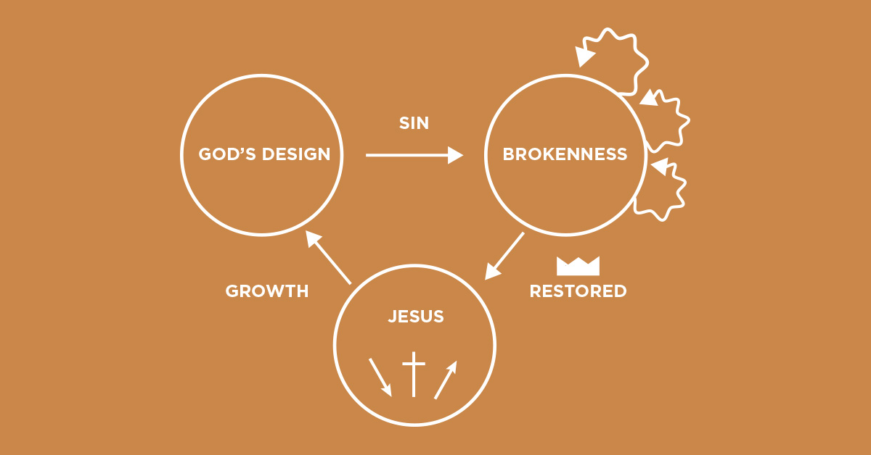

L: “That’s powerful!”

C: “Where do you see yourself in this picture?”

L points to *Brokenness*.

C: “And where would you like to be?”

L: “In God’s design.”

C: “You can get there right now. Larry, do you believe God raised Jesus from the dead?”

L: “Yes.”

C: “Larry, do you want to turn now from your brokenness?”

L: “Yes.”

C: “Would you confess to Jesus, not me, that you choose to follow Him as your king? Just tell him that!”

L: “Okay. Jesus, I turn from my brokenness and choose to follow you. Be the king of my life, Jesus!”

C: “Way to go Larry! Now let me show you some verses in the Bible!”

C opens to Matt. 28:18. “Jesus said, ‘all authority in heaven and on earth has been given to me.’ Do you believe Jesus has all authority in heaven and earth?”

L: “Yes.”

C: “Are you giving Jesus authority over your life?”

L: “Yes.”

C: “‘Therefore go and make disciples of all nations.” Larry, do you know what a ‘disciple’ is?”

L: “No,”

C: “It’s like an apprentice, following and becoming like Jesus! Do you want to be a disciple of Jesus?”

L: “Yes, but I don’t know how.”

C: “We will care for you and help you! Jesus continued, ‘baptizing them in the name of the Father and of the Son and of the Holy Spirit.’ Baptism is a symbol of what Jesus did for us—He died, was buried, and three days later rose from the dead! Baptism is also a picture of the miracle that happens inside us when we follow Him—we die to our old self and are raised up to walk a new life with Jesus! Will you obey Jesus’ example and command to be baptized now?”

L: “Yes, let’s do it!”

C: “Great. Now let me continue, ‘teach them to obey everything I have commanded you.’ Larry, can we come back and continue teaching you how to obey everything Jesus commanded?”

L: “Sure. When?”

C: “How about this same time next week?”

L: “Great!”

C: “Look at this last part, Larry. Jesus promised, ‘And surely I am with you always, to the very end of the age.’ Larry, how does that make you feel?”

L: “Really Good. Really Good.”

C: “Never forget Jesus’ promise to you, Larry! Now let’s go find water so you can obey Jesus’ command and be baptized!”

L: “Let’s Go!”

**Now spend some time with pen’s and paper telling God’s story…see if you can do it not looking at the notes.**

**Do you think this is a good way to lead someone to Christ? Which method…God’s story or my story from last week do you think is more effective?**

**INTO THE BIBLE**

**Read Luke 15.**

**Question #3**

There are 3 parables here told by Jesus. How do we see God’s story in each of these parables?

**Question #4**

Which of all the characters mentioned in Luke 15 do you think describes you?

**DIGGING DEEPER**

Spend some time naming and praying for someone you know is lost. How do you plan to help lead them to Christ?

How can we be intimate with God?