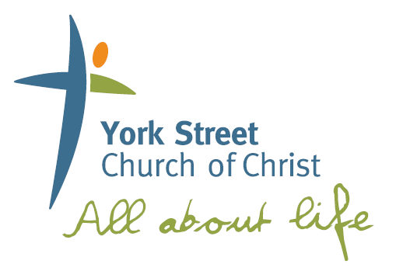

helping people **meet Jesus, become like Him** and be **equipped to impact** the local and global community

**York St Small Groups**

**Sermon Based Studies**

SUNDAY 23 JUNE 2019

Speaker: Tim Walter

**Family**

## **Deuteronomy 6:1-9**

Family



**Please note that these studies are designed to be explored after hearing the Sunday Sermon and also to be accompanied by a time of prayer/sharing and supper.**

**To listen to this message again please head to the**

**York St Website or download from iTunes.**

**Webpage: www.yorkst.com.au**

**GETTING STARTED**

helping people **meet Jesus, become like Him** and be **equipped to impact** the local and global community

helping people **meet Jesus, become like Him** and be **equipped to impact** the local and global community

**Q1**. At what age did you come to faith? Did you have someone share Biblical truths to you as a child?

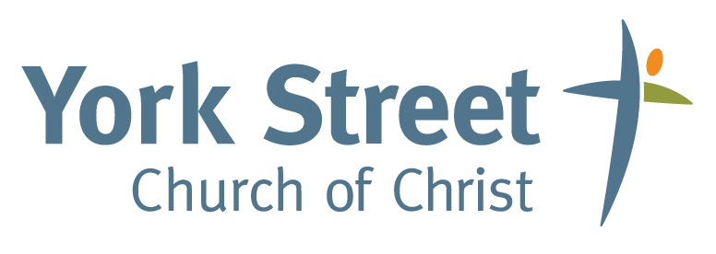

**Q2**. Who was influential in introducing you to Christ? Share your story of coming to faith.

**INTO THE WORD**

**Read Deuteronomy 6:1-9**

*Moses asks that God’s chosen people would not forget what God had done in Egypt, and that they would not forget the mighty things God had done in and through their time leaving slavery. He asks that they put God first with all they have and focused in on why it was so vitally important that the ‘nation’ raise the next generation in the faith.*

**Q3**. Why was it such a focus to ‘impress this’ on the children?

**Read Deut 6:1**

**Q4.** Deuteronomy completes a series of Biblical books called the Pentateuch, also known as the ‘Torah’ which include what is known as the books of the ‘law’. Moses starts this chapter with the urgency of WHY we need to obey (Deut 6:2-3). Do you think this is still relevant for today?

**Read Deut 6:4**

**Q5.** Moses summarises the laws so well that Jesus himself quotes this (Matthew 22:37). What does it look like to love the Lord our God with all we have?

**GOING DEEPER**

**Q6.** Deuteronomy 6:6-9 expands on what it looks like to have God at the centre of our lives. What does it look like to be ‘Christ Centred’ in our day to day lives?

**Q7.** If scripture speaks of the importance of passing on the ‘Love’ of God to the next generation how can we do that as an individual, as a small group and as a church? What can we do this week as a response to our Love of Christ to impact the generations to come? How will we be held accountable to this when we come back together next week?

**CONCLUSION & PRAYER**

The Pentateuch shows a sinful world separated from a loving God, yet God made a way for us to connect with Him and be set apart in a way that we would show His power and love to others. Ultimately this loving God sent his son Jesus to once and for all make a way back to a relationship with a perfect God. May we continue to learn to love Christ in a way that is shown in every aspect of our lives, and to impact the generations to come with the Love and Hope of Jesus Christ.

**Pray for one another.**